**Little Rubi’s Revenge**

Team Alien

GAM 541

Spring 2012



Vasileios Producer/Tools /AI Programmer

Santosh Technical Director/Engine Programmer/physics

Sree Harsha Game Designer/Game play/Physics/Sound Programmer

Zheng Graphics Programmer/Engine Programmer

Contents

Introduction 2

Game Flow 2

Game Mechanics 3

Game Characters & Environments 3

Game Controls 4

Audio Design 4

Physics and Behaviour Design 4

Visual Design 5

# 

# Introduction

Your girlfriend is the princess of the kingdom fez. She is in grave danger. Go save your love...or find another girlfriend if you fail. You need to do this by playing a side scrolling Plat former Game that combines fast paces game play with puzzle elements. Although it’s in 2.5d it used complete 3d graphics and physics. The goal is to make a game that is fun and interesting to play.

# Game Flow

The player starts by controlling the main character while familiarizing him with the game world and the mechanics .The game starts as a typical sidesroller which involves jumping to get across platforms and jumping on enemies to kill them. On the go he gets some powers like shooting and double jumping.etc.

Using the mechanics he has learned till now the player will have to solve some puzzles and kill enemies to get across to the end of the level. There will also be some sequences that are just shooting/melee attacking the enemies to get across the level.

For the purpose of completion, we are only focusing on the first level. A lot of the concepts we had for multiple levels will be worked into this one level and offer the player a broader experience. This can be a good thing, as the player has to quickly analyze situations to accomplish difficult puzzles. It increases the difficulty, which we were originally aiming for in later levels. After we are done with this level to perfection, we are thinking of adding many levels using these mechanics as we have a good level editor to do it very fast. We are aiming for one session to take around 15 minutes of game play to complete.

# Game Mechanics

The main character is controlled by the player and all the enemies are AI controlled. There are some moving platforms as well that are used to get across the level. You score points by killing the enemies and collecting collectibles. You win by saving the princess or finding a new girlfriend...or die trying.

The different statistics that we use are the hit points and the number of things you collect and will not go any deeper that that because it is not necessary for this game. For line of sight all we use is the direction of movement of the enemies as this is just a side scrolling platformer game.

# Game Characters & Environments

The main player is an alien and he is trying to save his princess who has been kidnapped by evil humans so he tries to save her and in the end finds a human girlfriend. The main character has different powers like shooting acid from the mouth, jumping. Even the enemies have these abilities. We have not yet decided on how the enemies and the hero look.

The game environments are futuristic chaotic world in the kingdom of fez. There are some spikes and lava floating around the world that do some damage to the player and also melt or break the blocks that are used to move around. The platforms are in the air floating around in the world. They are used for platforming. The game will have a vivid color pallet. Some different levels have different color pallet that show the mood of that particular game level, and of the world.

# Game Controls

The controls are simple for anyone to pickup and play the game. You control the character with the WASD keys and jump with the spacebar and aim and shoot with the mouse. And also use the mouse scrolling/number keys to change the weapons if the character is carrying more than one.

# Audio Design

We are experimenting with sound at the moment. We have been able to implement music and sound effects using FMOD. There will be a sound effect when the player interacts with the environment: jumping, shooting, dying, running into a wall, etc. The enemies would also likely have a sound effect attached to them. We will have a background music playing during the game. We have not yet decided on the kind of sounds we want to use. We will be using the DIGIPEN sound library to get sounds.

# Physics and Behaviour Design

We will use basic state machines and some path finding algorithms which are enough for this game. Physics will be very simple as we are sticking with a 2D plane for physics. We will be using a impulse based discrete physics system.

# Visual Design

The visual look of the game has a futuristic, funny aesthetic. It’s a 2.5d game with 3d graphics. The camera moves with the character with some padding for the character to move around the game. We have some motion blur and painting effect and some more effects will be added as we go on. The screen shot from our game below shows some effects that we are going for.

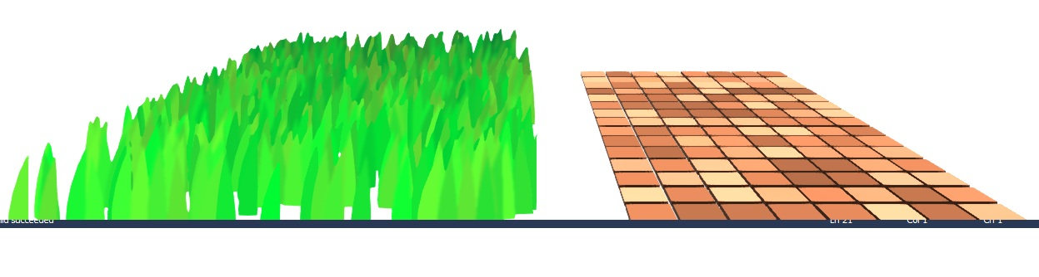

We are also going to add some good looking particle effects and different terrains like the ones seen above. The HUD will be very clean and easy to understand with all that is needed for the player to play the game and nothing more.

The models that we are creating will be low polygon models with a cartoonish look. To explain the story we are thinking of doing a comic book style story storytelling like that of maxpayne.